Chapter 5, Solution 34

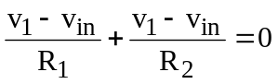 (1)

but
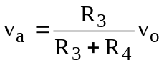 (2)

Combining (1) and (2),

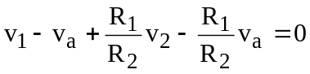

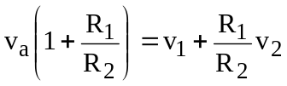

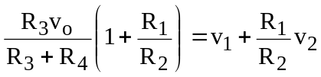

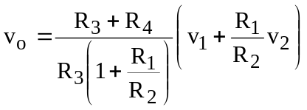

v_{O} = 